ANNOUNCEMENT
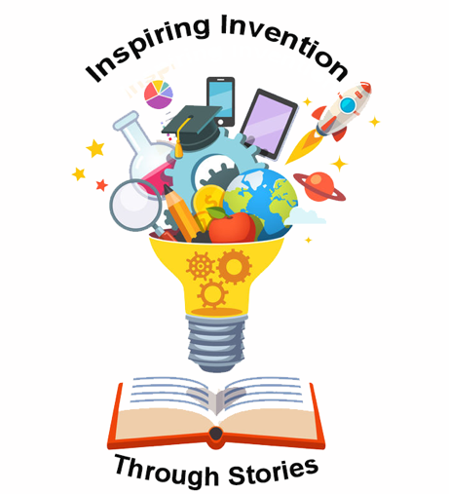
NEW LIBRARY PROGRAM!

Hello Parents!

We have exciting news! We are announcing a new program for children aged 4 to 8 called Inspiring Invention Through Stories. This program supports both literacy and inventive thinking for children in grades K-3. We hope you’ll enroll your child in fun educational program.

Each week, children will listen to a story that inspires creativity and inventive thinking and then take what they learn to help the fictional kids from Curiosity Creek, a rural American community, solve a problem. Through a series of story scenarios, children will meet the endearing Curious Kids, including Hector who loves to invent things and is always thinking of new inventions to solve problems (not always successfully) and sometimes just for fun.

They will enjoy using their imaginations and working together to explore ways to help the Curious Kids by learning to identify the problem and brainstorm possible solutions. Each week, the children will also have an opportunity to take their ideas and test them through a hands-on activity.
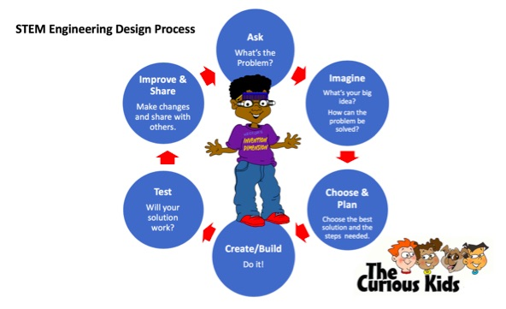
This program is intended to encourage children’s inventive thinking and develop the literacy skills of listening, reading, writing, and speaking to help prepare children to be better problem-solvers in school and later in life. And, because we know that parents can make a positive impact on children’s attitudes toward literacy and inventive thinking when they take an active role in these types of activities, we encourage you to stay with your child and see for yourself. We’ll also send home some ideas for how you can extend and enrich your child’s experiences from this program.

We invite you to drop by your library and enroll your child asap!

The design, development, and evaluation of this program for rural public libraries across the country was made possible, in part, through a National Leadership Grant from the Institute of Museum and Library Services (IMLS) and a partnership with Syracuse University. This program is an initiative of the nationally successful Young Innovators Project, featured on TheInnovationDestination.net.

